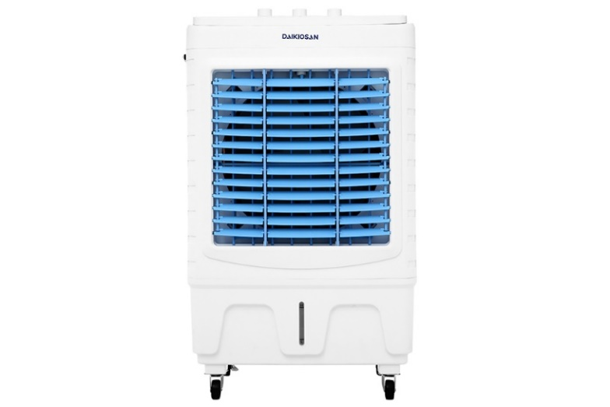

**3.790.000₫**

~~5.400.000₫~~ -29%

**Technical specifications of Daikiosan DKA-04500A air conditioner fan**

* Cooling range:

Room 25 - 30m²

* Wattage:

175W

* Wind speed:

3 wind levels

* Control:

Rotating knob

* Highest noise level:

50 dB

* Water bottle:

32 liters

* Utilities:

Automatically shuts off the pump when water runs out. There is a scale to display the water level. There is a sediment discharge valve in the water tank . There is a cooling dry ice box. There are moving wheels.

* Size, volume:

Width 60 cm - Height 100 cm - Depth 40.5 cm - 14 kg

* Brand of:

Vietnam

* Made in:

China

Introducing the company 

- Vietnamese brand, belongs to Dai Viet Refrigeration Electrical Engineering Joint Stock Company.

- Established in 2006 and known for household electrical products such as: coolers, water purifiers, kitchen appliances,... Received the promising strategic partner award from Dupont Group (predecessor Dow) – the world's leading corporation in chemicals and RO filter membrane supply.

- Daikiosan air conditioner fan is a high-end cooling product line, can be used for open spaces, with many power levels suitable for a variety of areas and spaces. From 2020, Daikiosan products are designed with an additional filter before the pump to filter hair and debris, helping to protect the pump impeller.

**Comes with 2**[**boxes of dry ice**](https://www.dienmayxanh.com/quat-dieu-hoa?g=co-hop-da-kho-lam-mat)**that when placed in the fan's dedicated dry ice compartment will increase cooling efficiency**

Dry ice is a type of chemical ice that can be reused. When you want to cool it, just put the box of dry ice in the freezer  [.](https://www.dienmayxanh.com/tu-lanh) After the ice is cold, put it in a dedicated compartment or water tank of the fan. , dry ice will cool the water so that the steam emitted is cooler.

If your home does not have a refrigerator to freeze dry ice, you can still use a cooling fan as usual with water.

[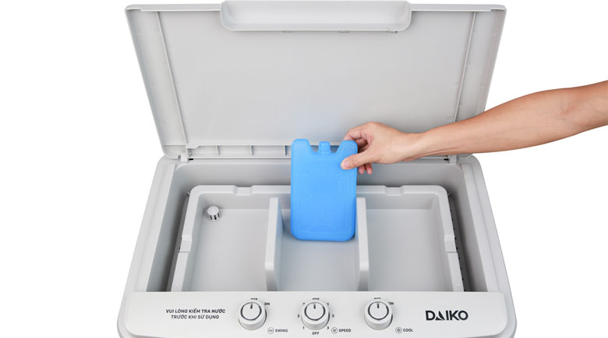](https://cdn.tgdd.vn/Products/Images/7498/218338/may-lam-mat-khong-khi-daikiosan-dka-04500a-3-1.jpg)

[**Daikiosan air conditioner fan**](https://www.dienmayxanh.com/quat-dieu-hoa-daikiosan)**(also known as air cooler) has a sturdy structure, bright colors, and moves gently with wheels below the fan body.**

Capacity 175W, air flow 4500 m³/h, good cooling in the range of 25 - 30m².

Copper wire motor operates smoothly and durable.0

[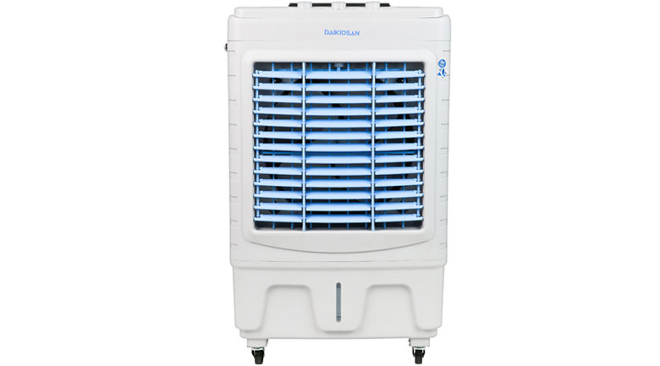](https://cdn.tgdd.vn/Products/Images/7498/218338/may-lam-mat-khong-khi-daikiosan-dka-04500a-1-1.jpg)

[**The highest noise level**](https://www.dienmayxanh.com/kinh-nghiem-hay/tim-hieu-ve-do-on-hay-con-goi-la-cuong-do-am-thanh-1166731)**reaches 50 dB like the sound in a soundproof movie theater**

When the machine is running, you and your family will not feel uncomfortable and can comfortably watch TV, listen to music,...

[**The air conditioning fan**](https://www.dienmayxanh.com/quat-dieu-hoa)**has a water tank capacity of 32 liters, gives 6 - 8 hours of use, does not need to be refilled many times, has a scale to display the water level**

Daikiosan steam fan thanks to the water level display scale helps you monitor the amount of water in the tank easily, add water quickly to help cool more effectively.

**With the feature of automatically shutting off the pump when the tank runs out of water, it increases the safety and durability of the product**

**Simple knob control panel, easy to operate**

- SWING: Knob to adjust the wind swing function.

- SPEED: 3 wind speed option knob from low - medium - high.

- COOL: On/off button for cooling steam generation function.

See more:  [How to use air conditioning fans](https://www.dienmayxanh.com/kinh-nghiem-hay/cach-su-dung-quat-dieu-hoa-831809)

[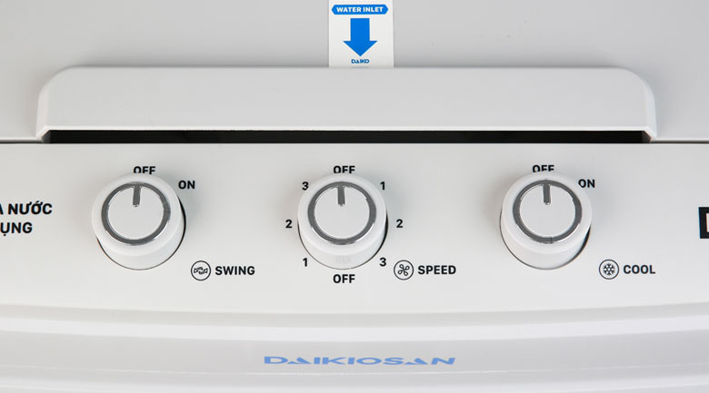](https://cdn.tgdd.vn/Products/Images/7498/218338/may-lam-mat-khong-khi-daikiosan-dka-04500a-2-1.jpg)

**Daikiosan DKA-04500A air conditioner fan, launched in 2019, Dai Viet company of Vietnam, manufactured in China**

**Note to use air conditioning fans effectively**

- Air conditioner fans only have the ability to cool the air, not the cooling ability like an air conditioner.

- Placing a fan in the corner of the room will help the wind spread throughout the room, providing a natural wind flow that is good for your health.

- Place the fan at least 20 cm away from the wall so that the fan has space to get air.

- Clean the fan regularly and the water in the tank is clean to avoid bacteria from growing, causing odors and affecting health.

- You should add water before plugging the power cord into the power source. If you are using a fan, turn it off and unplug the power cord before filling it with water, then start it up and use it again.

- Unplug the power cord when not using the fan to help save electricity better.

[Daikiosan DKA-04500A air conditioner fan](https://www.dienmayxanh.com/quat-dieu-hoa/may-lam-mat-khong-khi-daikiosan-dka-04500a) , a necessary cooling product for every family to cool down in the hot season with beautiful design, high durability and good consumer price.